Director: Prof. Francesco Annunziato

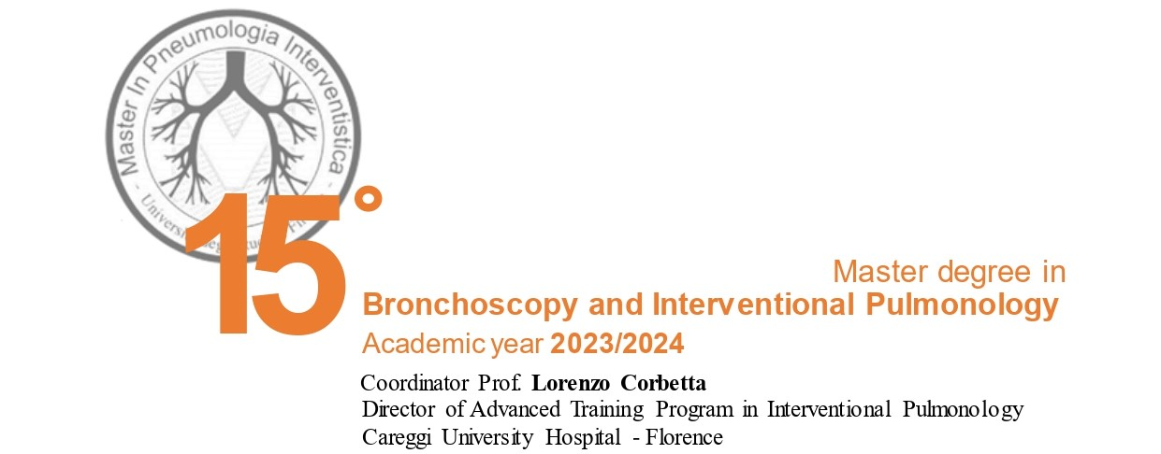

Scientific Committee
Lorenzo Corbetta, Firenze
Piero Candoli, Bologna
Giovanni Galluccio, Roma
Lucio Michieletto, Venezia
Marco Patelli, Bologna
Stefano Romagnoli, Firenze
Sara Tomassetti, Firenze
Luca Voltolini, Firenze
Simone Vanni, Firenze

Website:
http://master.pneumologia-interventistica.it/

Secretary:
segreteria.master@pneumologia-interventistica.it
lorenzo.corbetta@unifi.it

Endorsed by

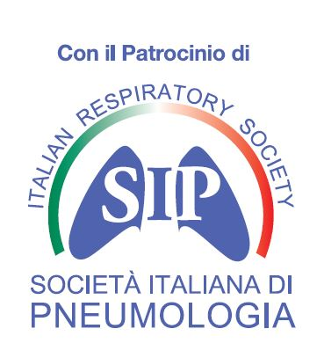

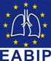

European Association of Bronchoscopy and Interventional Pulmonology

Master’s Values
- University Master 2nd level certification in Interventional Pulmonology valid as a curriculum title.
- 14 years of teaching experience that has led to a structured program, compliant with the core curriculum and international standards for the professional figure of the Interventional Pulmonologist with lessons carried out by leading Italian, foreign experts and qualified tutors.
- Innovative experiential teaching methods which are oriented to professional competence with the use of low and high fidelity simulation and log-book registration of the activities carried out by the learner.
- 3-week internship in centers distributed throughout the national territory.
- Reference manual created by the Master teachers: "Monography on competence in Interventional Pulmonology" - Ed. PanMinerva 2019 Torino.
- Website for communications and with the archive of the educational resources (http://master.pneumologia-interventistica.it) with an e-learning platform where you can find the recorded lessons, teaching material and scientific update.
- Teaching and evaluation sessions carried out at the Careggi University Hospital on working days to allow the attendance in the Endoscopic Room and in the new "Student Hotel" location on holidays.
- Quick connections to reach the center of Florence over the educational sites and agreements with hotels, restaurants and with “Firenze Card”.
- Publication of the final papers in indexed journals or with ISBN coding, valid requirement for public competitions.
- Inclusion of Master graduates in a national and international network for continuing professional development (Boot Camp, Workshops, Congresses).

Master degree in
Bronchoscopy and Interventional Pulmonology 2023/2024

Thoracic Endoscopy has developed fast in recent years thanks to the availability of new and more accurate instruments for the inspection of the bronchial tree together with the development of numerous new interventional procedures for the diagnosis and treatment of bronchopulmonary lesions. For this reason, the term Interventional Pneumology has been adopted internationally to define its strategic role in modern Pneumology for the diagnosis and treatment of neoplastic diseases of brochus, lung and pleura, lung interstitial diseases, infectious pathology and tracheobronchial stenosis, and the interventional nature of procedures such as bronchial and transbronchial biopsy, transbronchial needle aspiration (TBNA), endosonography, virtual and electromagnetic pulmonary navigation, laser-assisted tracheobronchial unblocking, prosthesis placement, thermoplastic, pulmonary volumetric reduction and artificial airway management. In this new scenario it becomes increasingly important for the Pneumology specialist to acquire theoretical and practical skills in Interventional Pulmonology through a targeted and long-lasting post-university teaching that starts from the physiopathological bases of respiratory diseases to arrive at the acquisition of the main manual skills of the discipline. Therefore the Master’s course aims to train a multi-purpose pulmonologist with professional skills in diagnostic and operative bronchoscopy, thoracoscopy, management of artificial airways through the synergistic contribution of University and Hospital professors.
The 15th Master in Interventional Pneumology follows the positive experience of the 14 previous editions which saw the participation of numerous specialists from all over the national territory. Since 2010, 350 physicians have been receiving a Master's degree in Interventional Pneumology: in very many cases they use their new skills and academic qualifications. Based on the acquired experience and international experiences, we have considered useful to treat the topics from 2 perspectives: the technical-procedural one and the analytical one, regarding the processes and diagnostic-therapeutic pathways that involve the execution of endoscopic procedures. Therefore, the most appropriate solutions will be proposed to the problems that are put to the Interventional Pulmonologist with the contribution of other specialties such as Thoracic Surgery, ENT, Radiology, Anesthesia and Resuscitation, Internal Medicine, Oncology. The teaching, leaded by experts from the University of Florence and the main Italian Centers of Interventional Pneumology, is mainly directed to medical specialists in respiratory system diseases and other specialists who have an interest in acquiring professionalism in this sector. The Master uses traditional frontal and seminar teaching methods together with innovative methodologies such as the use of virtual reality and manikins simulators, "real time" streaming connections with endoscopic rooms, e-learning sessions, videoconferences and different internships in the National centers.
The lessons are carried out in Flipped classroom mode which provides for the preliminary consultation the Moodle platform (https://scuola.med.unifi.it) of the lessons and teaching material, also valid as e-learning. The Master's course complies with International Standards, in particular those of the Association of Directors of International Pneumology Programs (AIPPD) for the standardization of interventional Pneumology scholarships based on the reports of the American Societies for the certification of professional activities. The assessment of competences is based, in addition to the lessons attendance, on the number of recorded procedures on a specific online logbook, on passing an MCQ (multiple choice questionnaire) examination, on the preparation of one paper (review and / or experimental study), on passing validated DOPS (Direct Observation Procedural Skill) on practical skills (B-STAT, EBUS-STAT, ENB-OCAT, UGSTAT).

Official texts: AA. VV. Monography on competence in Interventional Pulmonology - Ed. Panminerva 2019 Torino September; 61 (3). English and Italian Ed.
Competenze training in Pneumologia Interventistica – Ed. Minerva Medica 2024 – Italian and english edition
Theaching methodologies:
1) interactive theoretical session (flipped classroom);
2) problem based discussion with the support of digital tools;
3) hands on practice on low and high-fidelity simulators;
4) live sessions and streaming from the bronchoscopy suite;
5) final assessment of the competence by logbook and DOPS.

Starting of the lesson: 19th of February 2024

Scheduled program: 7 sessions of 3/5 days, 3 weeks of internship. Every session will be transmitted on a videoconference platform and uploaded in a Youtube channel with translation.

Locations:
- Aula Magna presso AOU Careggi, padiglione 6, Ex Presidenza Facoltà di Medicina
Largo Brambilla, 3
50134 Firenze
- Training Center presso AOU Careggi, padiglione 50/B
Viale Pieraccini, 11
50139 Firenze (FI)
- Sala endoscopica SOD presso AOU Careggi, padiglione 12C
Largo Brambilla, 3
50134 Firenze (FI)
- The Social Hub (ex Student Hotel) presso Firenze
Viale S. Lavagnini, 70
50129 Firenze (FI)
- Meyer Health Campus presso Firenze
Via Cosimo il Vecchio, 26
50139 Firenze (FI)
- Fondazione Internazionale Menarini presso Fiesole
Piazza Giuseppe Garibaldi, 30
50014 Fiesole (FI)

Official language: Italian, partially translated in english

Handbook: Monography on Competence in Interventional Pulmonology – Ed. Minerva 9/2019
Competenze training in Pneumologia Interventistica – Ed. Minerva Medica 2024 – Italian and
english edition

Organizing secretariat: segreteria.master@pneumologia-interventistica.it
Phone: Dr. Lorenzo Corbetta +39 3394834619
Dr. Chiara Del Corona +39 340 6713445

Learning Targets - To achieve theoretical and practical knowledge in the following topics:

Basic competence
• Thoraco-pulmonary anatomy and histology and pathological anatomy of the main thoraco-pulmonary diseases.
• Thoraco-pulmonary radiological and surgical anatomy
• Thoraco-pulmonary physiopathology
• Professional accreditation, structure and medical-legal aspects in interventional pneumology.
• Training and computerization of interventional pulmonology facilities
• Risk management in Interventional Pneumology (check list, audit, M&M)
• Health Technology Assessment
• Interventional Pulmonology in Health Governance

Competence-oriented teaching (Knowledge, Skills, Attitude) - TOPICS
Part A: Disease-specific basic knowledge requirements
Lung cancer and solitary  pulmonary nodule | - Diagnosis, staging and natural history of thoracic malignancies to include lung cancer, mesothelioma, thymoma, lymphoma  - Pathology of lung cancer  - Indications, contraindications, limitations, complications, techniques, and interpretation of results of diagnostic and therapeutic procedures  - integral to the discipline, including the appropriate indication for and use of screening tests/procedures as well as the risks and benefits of alternative procedures  - Collaboration among specialists in the management of lung cancer:  - multidisciplinary thoracic tumor board  - Undiagnosed mediastinal and hilar lymphadenopathy
Malignant and non-  malignant central airway disorders | - Malignant central airway disorders  - Non-malignant central airway obstruction due to:  - Tracheal/bronchial obstruction secondary to, for example, granulomatosis with polyangiitis, post-intubation/tracheostomy, tuberculosis, sarcoidosis, amyloidosis, recurrent respiratory papillomatosis, broncholithiasis, tracheal/bronchial malacia / excessive dynamic airway collapse secondary to relapsing polychondritis, Mounier-Kuhn syndrome, COPD  - Foreign bodies  - Vocal cord disorders  - Airway complications following airway surgery/lung transplant to include anastomotic strictures/granulation  - Airway stent-associated granulation tissue  - Extrinsic compression from, for example, goitre, mediastinal cyst, lymphadenopathy  - Pathophysiology and radiographic interpretation of central airway obstructions  - Strategy on endoscopic and surgical treatment
Interstitial lung  diseases and granulomatosis | - Classification, epidemiology, etiology, clinical and endoscopic diagnosis, treatment and follow-up of interstitial lung diseases  - Radiographic (CT-Scan) interpretation of the main patterns of ILD and granulomatosis  - Indication for interventional bronchoscopic diagnosis (BAL, transbronchial biopsy and needle aspiration, cryobiopsy) and for surgical biopsy
Pulmonary  infections | - Classification, epidemiology, etiology, clinical and endoscopic diagnosis, treatment and follow-up of pulmonary infections  - Radiographic and blood chemistry interpretation of pulmonary infections  - Indication for interventional diagnosis (BAL, transbronchial biopsy and needle aspiration)  - Management of critical phases of pulmonary infection
COPD and Asthma | - COPD  - Pathophysiology, classification, imaging and treatment of severe COPD  - Indications for the endoscopic treatment of emphysema  - Asthma  - Pathophysiology and treatment of severe asthma  - Differential diagnosis of asthma  - Indications for the endoscopic treatment of asthma(thermoplasty)
Pleural diseases | - Parapneumonic effusion and empyema  - Malignant pleural effusions  - Malignant mesothelioma  - Recurrent non-malignant pleural effusions (chylothorax, hepatic hydrothorax / effusions due to refractory congestive heart failure)  - Pneumothorax  - Pleural fistulas  - Knowledge of differential diagnosis and treatment through non-invasive (radiographic imaging, thoracic ultrasound) and invasive procedures (medical thoracoscopy with parietal pleural biopsy and pleurodesis, pleural catheter placement: chest tube, small bore catheter, and implantable tunnelled catheters, percutaneous pleural biopsy, VATS)
Part B: Skills in diagnostic and operative procedures
Flexible bronchoscopy and basic biopsy technique | - Flexible bronchoscopy and basic biopsy techniques: endobronchial biopsy, transbronchial biopsy, TBNA, ROSE, BAL, brushing
Endosonographic techniques | - Interventional endosonography (EBUS, EUS, EUS-B): Mediastinal and hilar lymph node sampling using convex endobronchial ultrasound
Bronchoscopic navigation | - Navigation, guided transbronchial biopsy (guided-TBB) for peripheral pulmonary lesions (PPL) and cryobiopsy for Interstitial Lung Disease (ILD) : image-guided or computer-guided diagnostic bronchoscopy for evaluation of parenchymal opacities, of airway invasion vs compression, and to guide biopsy: fluoroscopy, electromagnetic pulmonary navigation, EBUS-radial probe and cryobiopsy, Cone Bean and augmented fluoroscopy, Robotic bronchoscopy
Operative bronchoscopy | - Rigid bronchoscopy with the following associated procedures:  - Rigid core and mechanical debulking  - Endobronchial ablative techniques using one or more of the following devices: Laser, Argon plasma coagulation, Electrocautery, Cryotherapy  - Photodynamic therapy  - Placement and removal of endobronchial stents (silicone, hybrid, dynamic)  - Rigid sequential dilatation  - Foreign bodies removal  - Management of massive hemoptysis  - Endoscopic treatment of emphysema and severe asthma  - Markers implant  - 3D stent
Pleural procedures | - Medical thoracoscopy with parietal pleural biopsy and pleurodesis  - Pleural catheter placement (chest tube, small bore catheter, and implantable tunnelled catheters)
Thoracic ecography | - Thoracic ultrasound to assess and guide interventions in the pleural space
Bronchoscopy in ICU, anaesthesiology, and thoracic surgery | - Bronchoscope intubation in difficult airways  - Management of endotracheal tubes, double lumen tubes and laryngeal mask  - Management of tracheostomy tubes  - Tracheobronchial aspiration to drain secretions  - Diagnosis of pulmonary infiltrates, VAP and ARDS in ICU  - Percutaneous dilatational tracheostomy placement and management  - Use and integration of interventional procedures in the management of surgical interventions: mediastinoscopy, thoracotomy and lung resection, thoracoscopy and video-assisted thoracoscopy, surgical management of empyema, lung volume reduction surgery, lung transplantation, laryngeal/tracheal resection and reconstruction, tracheoplasty, suspension laryngoscopy, open surgical tracheotomy, pulmonary sequestration, and management of other malformations, cystic lesions, empyema  - Clinical and surgical staging of lung cancer, Diagnosis and treatment of surgical complications: loss of airway integrity; anastomotic dehiscence, tracheobronchial/esophageal fistula, broncho-pleural/alveolar-pleural fistula; management of chest drainage
Emergency in Interventional Pulmonology | - Bronchoscopic management of massive hemoptysis, foreign body, thoracic trauma, central airway obstructions and lesions, surgical complications  - Pediatric thoracic emergency
New treatments in asthma and COPD | - Endoscopic treatment of emphysema and severe asthma  - Rheoplasty

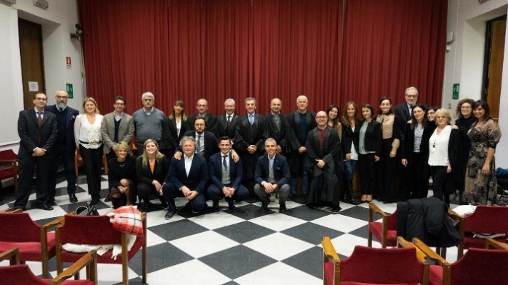
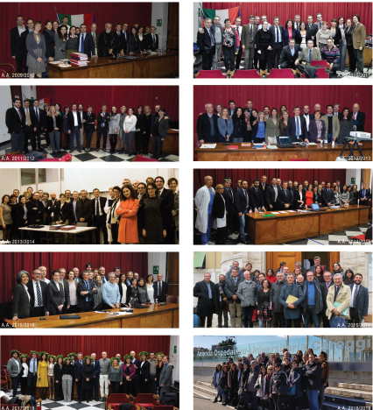

A.A. 2019-2020

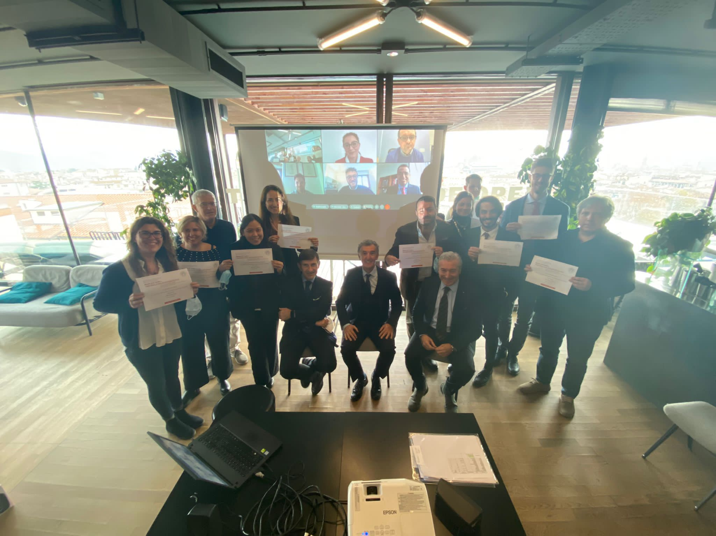
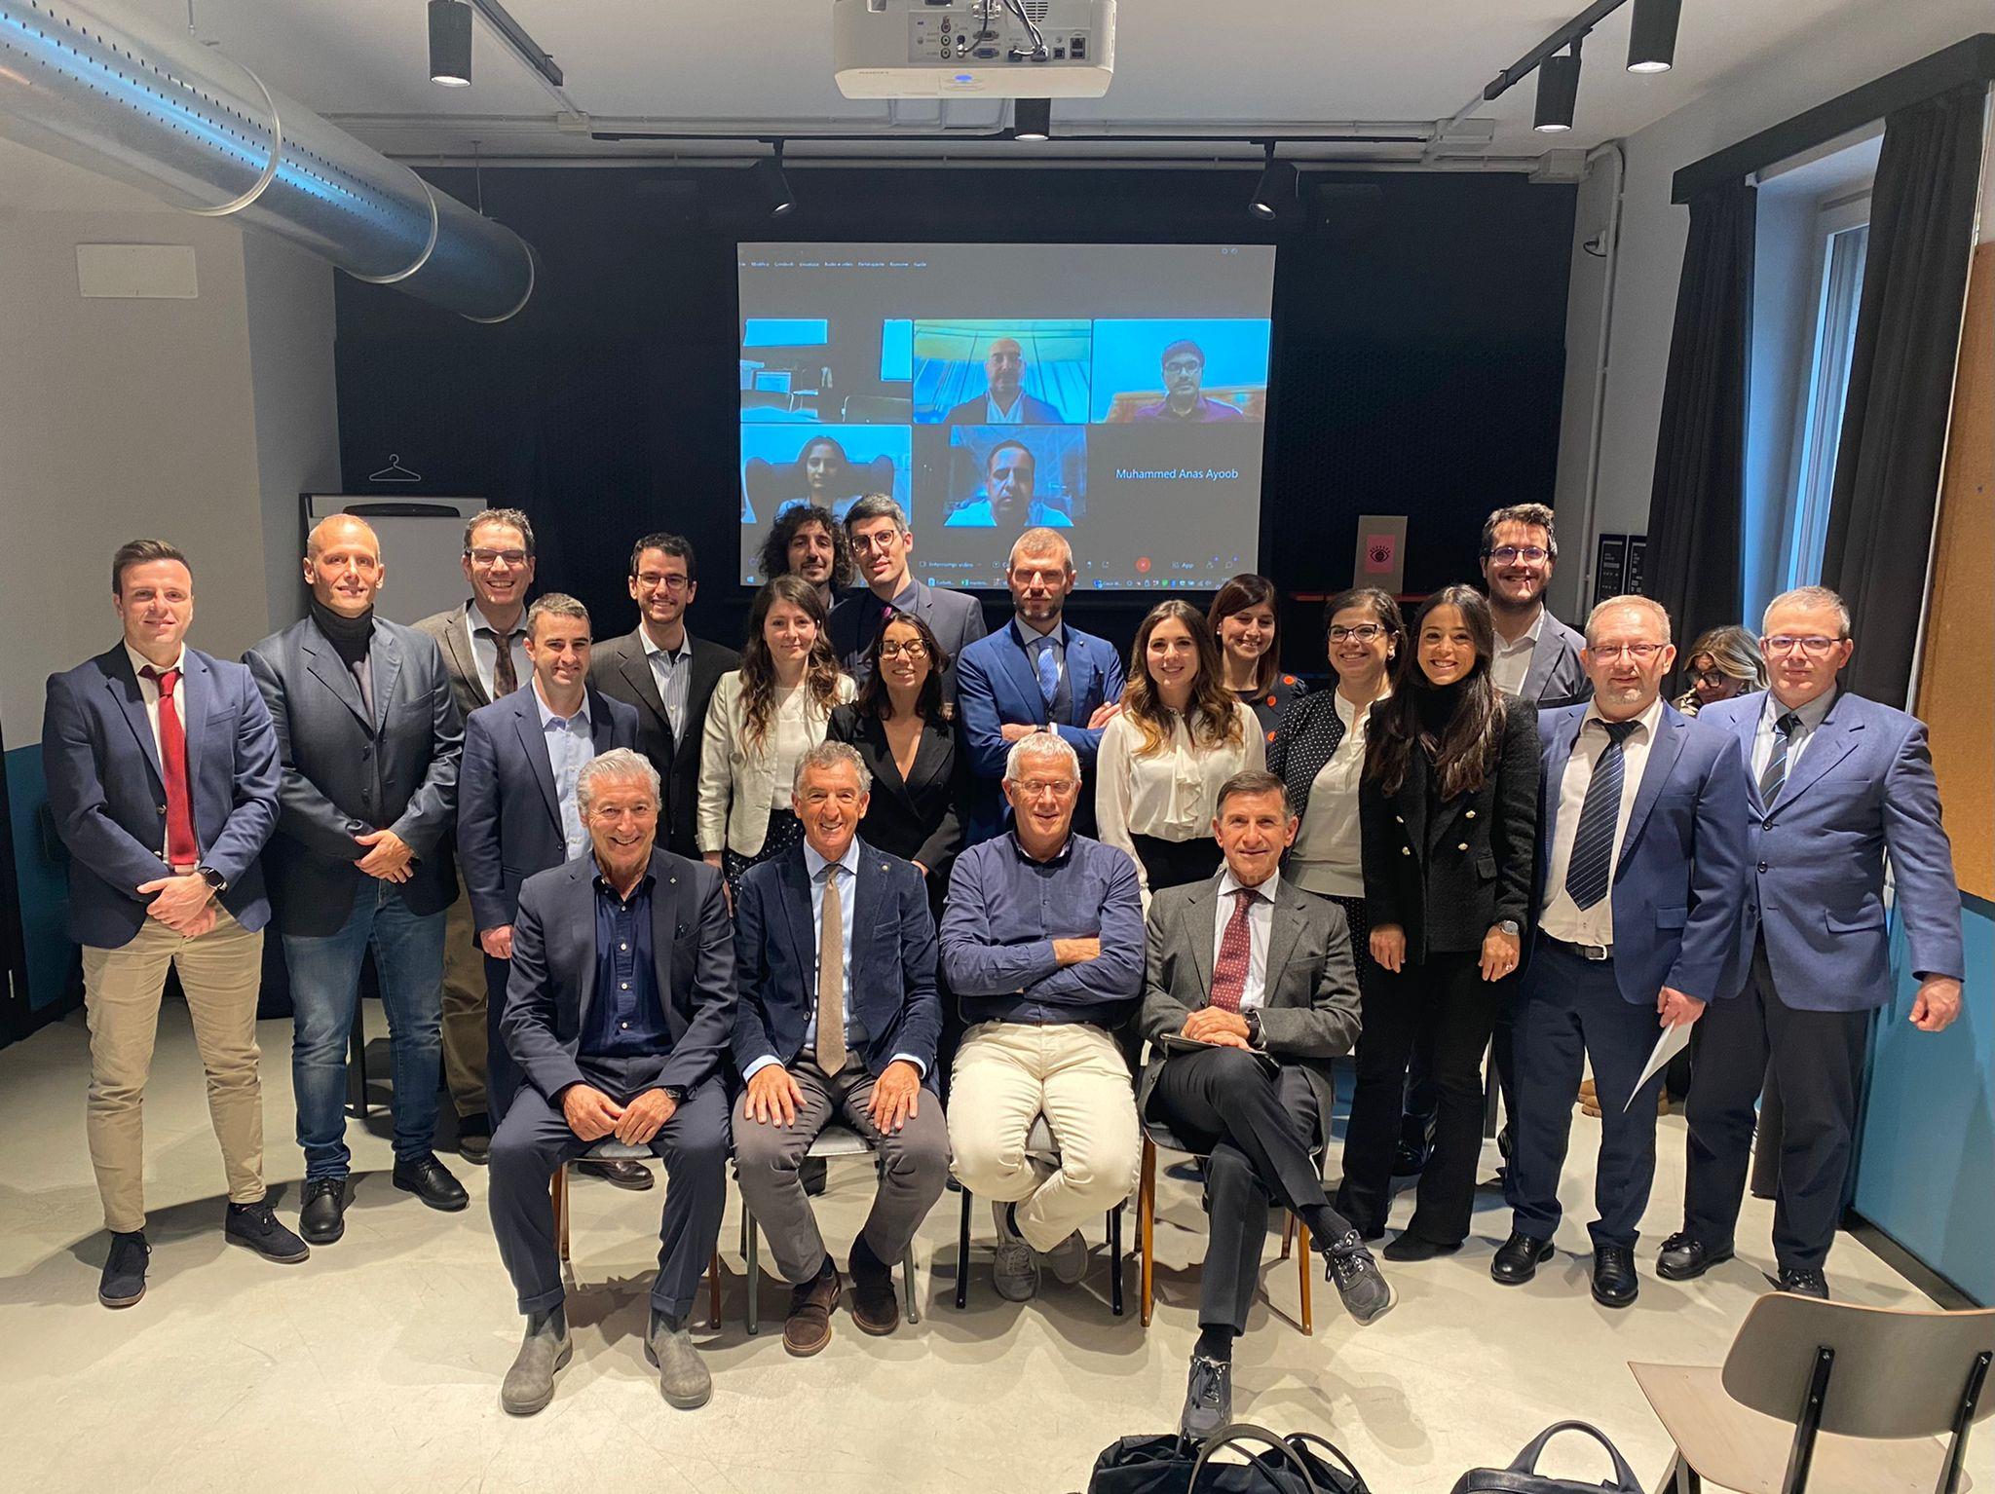

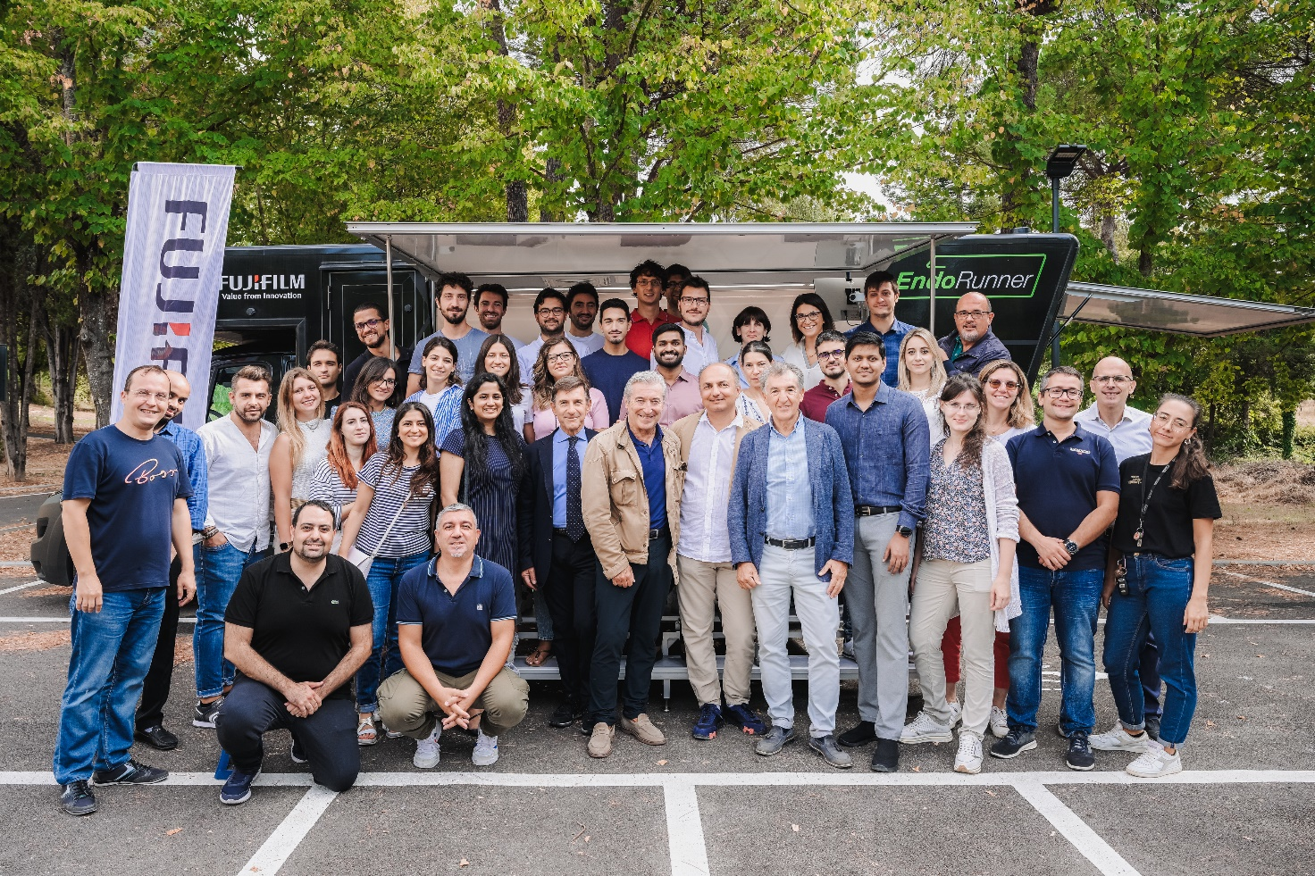
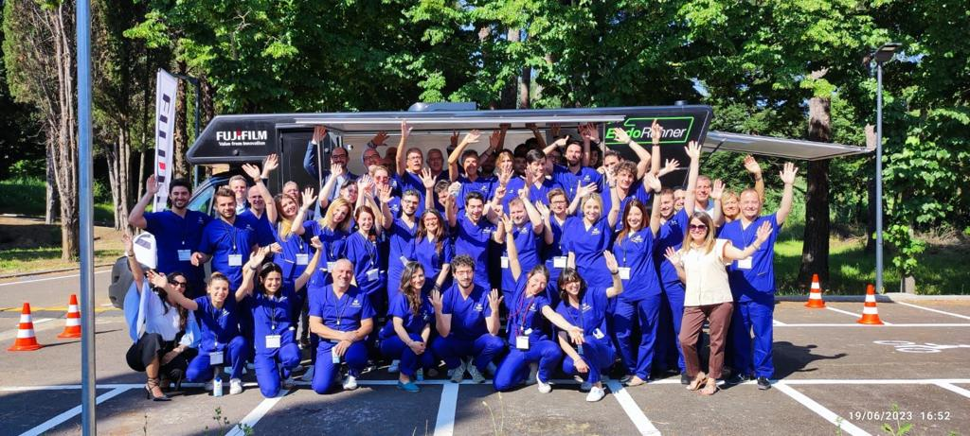

2009-2019
10 years of Master in Bronchoscopy and Interventional Pulmonology

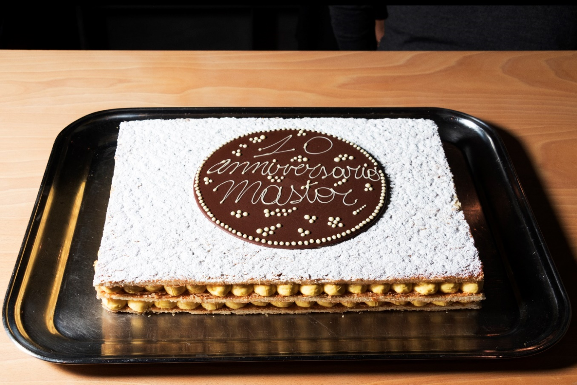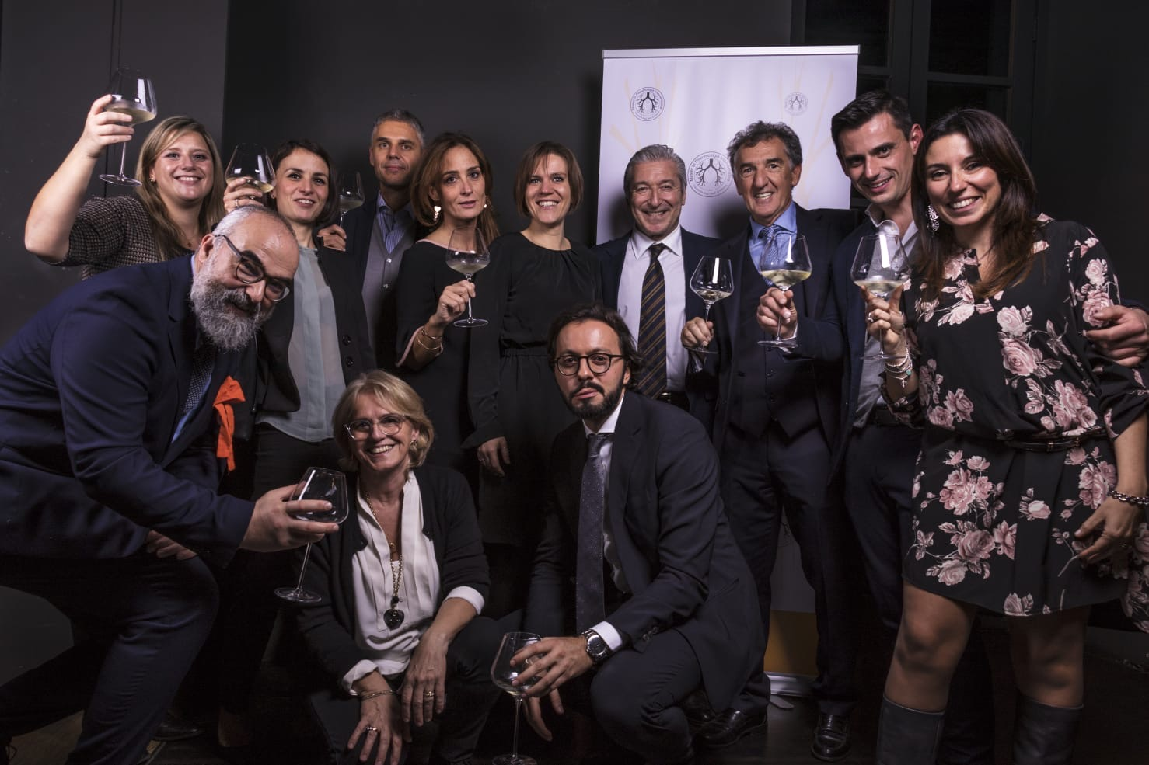

Short program
Sessions | Workshops
19th of February 2024, 2.30pm: Opening Ceremony
- Lecture: Training and Competence in Interventional Pulmonology: the Master experience
- Presentation of the faculty and participants
- Presentation of the program
- MCQ Assessment
1st session: 20th to 22th of February
- Basic bronchoscopy and biopsy techniques
- ROSE
- Live Streaming from the Endoscopy Suite
- Live or prerecorded lessons
- Flipped Classroom and problem based discussion
- Q&A with the participants

2nd session: 15th to 19th of April  - Live Streaming from the Endoscopy Suite  - Live or prerecorded lessons  - Endosonography  - Pulmonary navigation  - Operative bronchoscopy  - Anesthesia in flexible and rigid bronchoscopy  - Flipped Classroom and problem based discussion  - Q&A with the participants | Workshop 1:  19th of April  Update on Lung Tumor and Multidisciplinar Team Discussion
3rd session: 28th to 31st of May
- Live Streaming from the Endoscopy Suite
- Respiratory infections
- Pleural diseases, pleural procedures, thoracoscopy
- Integrated treatment of Emphysema
- Thoracic Echography
- Hands-on Practice in bronchoscopy, EBUS, rigid bronchoscopy and pleural procedures with simulators
- Q&A with the participants

4th session: 13th to 18th of June
- Live Streaming from Endoscopy Suite
- Hands-on practice in broncoscopy, EBUS, rigid bronchoscopy and pleural procedures with simulators
- Problem based discussion
- Flipped classroom
- Practical Assessment
- Q&A with the participants

5th session: 16th to 19th of September  - Bronchoscopy in Emergency, anaesthesia and UTI  - Paediatric bronchoscopy  - Cryobiopsy and interstitial lung diseases  - Hands-on Practice in bronchoscopy, EBUS, rigid bronchoscopy and pleural procedures with simulators  - Problem based discussion  - Flipped classroom  - Q&A with the participants | Workshop 2:  17th of September  Update on Diffuse Lung Disease and Crybiopsy and MDT
6th session: 10th to 12th of October  - Thermoplasty in Asthma  - Hands-on Practice in bronchoscopy, EBUS, rigid bronchoscopy and pleural procedures with simulators  - Case Based Discussion  - Flipped classroom  - Practical Assessment  - Preparation of the final thesis  - Q&A with the participants | Workshop 3:  11th of October  Integrated treatment bronchial asthma and emphysema
May to October 2024: Internships in the IP National Centres
10th of October 2024: Final MCQ assessment
28th of October 2024: Final examination and Diploma

General indications:
Each lesson lasts 45'- 1h including discussion.
Morning streaming are additional but contribute 50% of the internship hours and the other 50% of on-site practice hours.
During the streaming one or more operators from the Unit of Interventional Pulmonology and two experts will comment the operations. There could be more than one room in connection.
Attendance of at least 2/3 of the lectures is required. Interactive online attendance with camera on is considered 50%.
Practical activities (in blue) and the internship are mandatory at 70%.
It is mandatory to do 3 weeks of internship in one or more national Interventional Pulmonology centres.
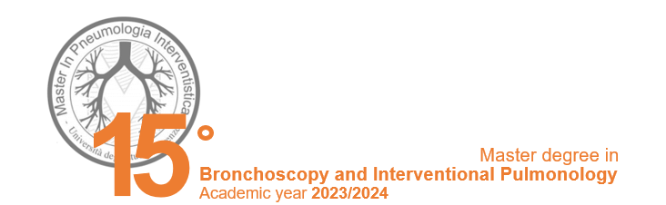

I SESSION: 19th-22nd of February 2024
Opening ceremony
Basic bronchoscopy

Monday, 19th of February – Open Ceremony - Aula Magna ex Presidenza Careggi

2.30pm - 3pm | Introduction and Welcome of the participants | Academic authorities:
 |  | F. Annunziato
 |  | (Direttore
 |  | Dipartimento DMSC –
 |  | R. De Angelis (RAD
 |  | DMSC)
 |  | Master Coordinator:
 |  | L. Corbetta
3pm - 4pm | Presentation of Faculty and participants | S. Tomassetti, P. Candoli, M. Patelli, G. Galluccio, L. Michieletto, L. Lazzari, M. Trigiani, V. Luzzi, R.M. Piperio, L. Ciani, L. Giuntoli
4pm - 5pm | From Bronchoscopy to Interventional Pulmonology | M. Patelli
5pm - 6pm | Program and organization of the Master | L. Corbetta, C. Del Corona, E. Piampiano
Tuesday, 20th of February – Aula Blu Meyer Health Campus

 |  | Chairmen: L. Corbetta, P. Candoli
8.30am - 1.30pm | Live streaming from endoscopic room | L. Corbetta, S. Tomassetti, M. Trigiani V. Luzzi, R.M. Piperio, S. Cannistrà
 | Lunch break
2.30pm - 3.15pm | Training and competence in Interventional Pulmonology: the Master’s experience | L. Corbetta
3.15pm - 4pm | Thoracic Anatomy and virtual autopsy (Anatomage/Sectra) | F. Paternostro
4pm - 5pm | Radiological anatomy of the lung and mediastinum | C. Moroni, A. Bindi, E. Cavigli, D. Cozzi
5pm - 6pm | Bronchoscopic anatomy of the airways and mediastinum | L. Corbetta
Wednesday, 21st of February – Aula Magenta Meyer Health Campus

 |  |  | Chairman: L. Corbetta
 | 8.30am - 1.30pm | Live session Video streaming with endoscopic room | Coordination: L.  Michieletto, L. Lazzari
 |  | Lunch break
 | 2.30pm - 4pm | Diagnostic bronchoscopy: general aspects (structure, tools and personnel) | L. Lazzari
 | 4pm - 5pm | Contraindications to bronchoscopy and anti-aggregant/anticoagulant guidelines in pneumology. | A. Comel
 | 5pm - 6pm | Indications for bronchoscopy and strategies for correct sampling | L. Corbetta

Thursday, 22nd of February – Aula Blu Meyer Health Campus
TEST: informatic room Cubo 1, viale Pieraccini 6

 |  | Chairman: L. Corbetta
8.30am - 9.30am | Sampling techniques; biopsies, TBB, TBNA and more | M. Majori
9.30am - 10.30am | Sampling techniques: BAL and ROSE | G. Marcianò
10.30am - 11.30am | Cytoassistance | C. Maddau
11.30am - 12.30pm | Management of endoscopic sampling in neoplasms and granulomatosis | V. Livi
12.30pm - 1.30pm | Importance of histological sampling in the diagnosis of sarcoidosis | M. Bonifazi
2pm – 4pm | Admission test - Valuation MCQ

II SESSION: 15th-19th of April 2024
Endosonography
Pulmonary Navigation
Sedation and Anesthesia
Monday, 15th of April – The Social Hub (ex Student Hotel)

 |  | Chairmen: L. Corbetta, P. Candoli
9.15am – 9.30am | Introduction | L. Corbetta, T. Toma
9.30am – 10.30 | Strategy and role of mediastinal endosonography in the diagnosis and staging of NSCLC | M. Romagnoli
10.30am - 11.30am | Instruments and accessories of endosonography | P. Candoli
11.30am - 12.30pm | EBUS Cryonode biopsy | H. Gonuguntla
12.30pm - 1.30pm | EUS | A. Rozman
 | Lunch Break | Chairmen: L. Michieletto,  M. Romagnoli
2.30pm - 3.15pm | Body vision | P. Candoli
3.15pm - 4pm | Ultrathin bronchoscope | L. Zuccatosta
4pm - 5pm | Radial EBUS in the pulmonary nodule | L. Michieletto
5pm - 5.30pm  5.30pm - 6.30pm | Archimedes  EMN and Cone bean CT/AF | N. Facciolongo  E. Van Der Heijden

Tuesday, 16th of April – The Social Hub (ex Student Hotel)

8am - 1.30pm | Live session Video streaming from endoscopy room | Chairmen: L. Corbetta,  L. Michieletto
 | Lunch break
3.30pm - 5.30pm | Bronchoscopic sedation | Chairmen: P. Fontanari, L. Corbetta
3.30pm - 4.30pm | General anesthesia in flexible and rigid bronchoscopy | A. Bechi
4.30pm – 5.30pm | Bronchoscopic sedation menaged by pulmonologist | L. Michieletto
5.30pm – 6.30pm | Discussion with presentations by National Centres | G. Galluccio, P. Candoli

Wednesday , 17th of April – Morning: Lorenzo il Magnifico room Meyer Health Campus
Afternoon: Training Center AOU Careggi
[in collaboration with WABIP]

8.30am – 10.30pm | Live session Video streaming from endoscopy room | Chairmen: L. Corbetta, M. Patelli
10.30pm - 6pm | International workshop  Navigation systems: new insights | Chairmen: L. Corbetta, P. Candoli, R. Trisolini, Ali Musani
10.30am – 11.30am | Navigation, lung vision | A. Abramovic
11.30pm – 12.30pm | Navigation system and Robotics for thermoablation | Calvin NG
12.30pm – 1.30pm | Monarch Robotic navigation | S. Murgu
 | Lunch break
2.30pm – 3.30pm | The Role of Robotic Bronchoscopy in Early Detection and Evaluation of Lung Nodule | A. Alraiyes
3.30pm – 4.15pm | Management of ground glass opacities: which algorithm for decision-making? | E. Van der Heijden
4.15pm – 5pm | Pulmonary Nodules: tips and tricks | C. Argento
5pm – 5.45pm | Ion robotic navigation | M. Pritchett
5.45pm – 6.30pm | Galaxy robotic navigation | ?

Thursday, 18th of April – Morning: Lorenzo il Magnifico room Meyer Health Campus
Afternoon: Training Center AOU Careggi

8am - 1.30pm | Live session Video streaming with endoscopy room Problem based discussion  Technological Corner | Chairmen: L. Corbetta, P. Candoli
 | Lunch Break
2.30pm - 3.30pm | Reading: cytoinclusion, clot core, TBB, cryobiopsy the opinion of the pathologist | C. Comin, V. Pasini
3.30pm - 6.30pm | Histological and cytological examination on slide: presentation of clinical cases | Chairmen: L. Corbetta, S. Tomassetti  C. Comin, S. Cannistrà, V. Pasini, L. Ciani, L. Giuntoli, G. Pompeo

8.30 – 9.15 | Apertura della segreteria e registrazione partecipanti
9.15 – 9.30 | Introduzione del corso | L. Corbetta, K. Ferrari
9.30 - 12.30  12.30 - 13.00 | Live session Video streaming con la sala endoscopica  Discussione su casi e procedure | Chairmen: L. Corbetta, L. Michieletto  L. Ciani, L. Giuntoli, M. Trigiani, V. Luzzi, S. Cannistrà  P. Candoli , G. Galluccio
 | Pausa pranzo
 |  | Chairmen: M. Trigiani, L. Corbetta
14.00-14.20 | Il ruolo del GOM nelle decisioni diagnostico-terapeutiche | K. Ferrari
14.20 - 14.40 | Le risorse dello pneumologo interventista nell’ottimizzazione del prelievo | L. Corbetta
14.40 – 15.00 | La diagnosi broncoscopica delle lesioni periferiche del polmone | P. Candoli
15.00 – 15.20 | Le risorse del radiologo interventista nell’ottimizzazione del prelievo | F. Mondaini
15.20 - 15.40 | Ruolo della citologia e della ROSE | C. Maddau, S. Cannistrà
15.40 - 16.00 | Il preparato istologico ideale | C. Comin, V. Pasini
 | Coffee break
 |  | Chairmen: A. Grosso, C. Moroni
16.20 - 16.40 | NGS | S. Von Borries
16.40 - 17.00 | Nuove tecniche di chirurgia del tumore polmonare e terapie complementari | L. Voltolini
17.00 - 17.20 | Terapia adiuvante e neoadiuvante e ruolo dei prelevatori | F. Mazzoni
17.20 - 17.40 | Terapia dello stadio IIIb e IV e ruolo dei prelevatori | V. Scotti
17.40 - 18.30 | Problem based discussion: Membri GOM | Coordinatore: A. Grosso
18.30 | Chiusura dei lavori | K. Ferrari, L. Corbetta
Workshop: 19th of April 2024
Highlights in the multidisciplinary management of lung tumor
Friday, 19th of April – Auditorium Meyer Health Campus

III SESSION: 28th-31st of May 2024
Operative bronchoscopy
Lung tumor and multidisciplinary team
Integrated treatment of pulmonary emphysema
Bronchoscopy in infectious diseases
Live video streaming session with the endoscopy room
Practical sessions

Tuesday, 28th of May – The Social Hub (ex Student Hotel)
9am - 1pm | Hands-on practice with simulators | T. Toma, M. Trigiani, T. Galasso, P. Candoli M. Patelli, G. Galluccio, C. Maddau, S. Cannistrà, V. Luzzi, L. Michieletto, A. Tofani
 | Lunch break
2pm – 6pm | Hands-on practice with simulators | T. Toma, M. Zanobetti, L. Sammicheli, M. Romagnoli F. Montinaro, L. Lazzari, M. Trigiani, T. Galasso, P. Candoli M. Patelli, G. Galluccio, S. Scarlata, C. Maddau, S. Cannistrà, V. Luzzi, L. Michieletto, E.Van Der Heijden

Wednesday, 29th of May – The Social Hub (ex Student Hotel)
10am - 1pm | Hands-on practice with simulators | T. Toma, M. Trigiani, T. Galasso, P. Candoli M. Patelli, G. Galluccio, C. Maddau, S. Cannistrà, V. Luzzi, L. Michieletto, A. Tofani
 | Lunch break
2pm – 6pm | Hands-on practice with simulators | T. Toma, M. Zanobetti, L. Sammicheli, M. Romagnoli F. Montinaro, L. Lazzari, M. Trigiani, T. Galasso, P. Candoli M. Patelli, G. Galluccio, S. Scarlata, C. Maddau, S. Cannistrà, V. Luzzi, L. Michieletto, E. Van der Heijden

Thursday, 30th of May – Auditorium Fondazione Menarini, Fiesole
Pharmacological and non-pharmacological treatment of COPD
9am – 6pm  9am – 9.20pm | Treatment of Emphysema in the GOLD Guidelines | Chairmen: T. Toma, F. Lavorini  T. Toma
9.20am – 10am | Endoscopic treatment of Emphysema in CV – and CV + patients | K. Klooster
10am -10.40am | Endoscopic treatment of chronic bronchitis | J. Hartman
10.40am – 11.15am | Break
11.15am – 12pm | Centered treatment of emphysema with thermal vapor | F. Herth
12pm – 12.20pm | Alternative indications of endobronchial valves: Air leaks | L. Zuccatosta
12.20pm – 12.50pm | Endoscopic treatment of tuberculous caverns and mycobacteriosis | V. Luzzi
12.30pm – 1pm | Discussion
 | Lunch break
2.30pm – 3pm | Infectious diseases (pneumonia, TB, Mycobacteriosis, COVID): role of bronchoscopy | L. Michieletto
3pm – 3.30pm | Microbiological classification of respiratory infections | K. Koroveshi, G. Rossolini
3.30pm – 4.40 | Management of TB and emerging infections | PG Rogasi
4.30pm – 5pm | Management of NTM | J. Mencarini
5pm – 5.20pm | Presentation of the study Valves for Management of T and NTM cavities | L. Corbetta

Friday, 31st of May – Auditorium Fondazione Menarini, Fiesole [collaboration with SIET]
 |  | Chairmen: M. Patelli, G. Cardillo
9am – 9.30am | Operative bronchoscopy tools: Rigid bronchoscope, Laser, cryo, APC, PF electrocautery | P. Foccoli
9.30am – 10am | Endoscopic treatment of benign strictures | M. Patelli
10am – 10.30am | Endoscopic treatment of tumors of the trachea and high stenosis | A. Marchioni, F. Mattioli
 | Break
11am – 11.30am | Surgery of the trachea | L. Voltolini
11.30am – 12pm | Operative bronchoscopy: fistula treatment | G. Galluccio
12pm – 12.30pm | Role of bronchoscopy in lung transplantation | P. Solidoro
12.30pm – 1pm | Discussion | P. Cardillo
 | Lunch break
 |  | Chairmen: H. Datau, G. Stratakos, P. Candoli
2.30pm – 3pm | The history of the stent | H. Dutau
3pm – 3.30pm | Tracheal replacement: where are we at the present time? | E. Martinod
3.30pm – 4pm | Could 3D printed stents be an option? | N. Guibert
4pm – 4.30pm | Active stents | Toni Rosell
4.30pm – 5pm | Biodegradable stents | K. Darwiche
5pm – 5.30pm | Conclusion remarks | G. Stratakos
5.30pm – 6pm | Discussion | D. M. Radu, I. Onorati

IV SESSION: 13th – 18th of June 2024
Pleural pathologies and procedure and thoracoscopy
Thoracic ultasound
Live video streaming from endoscopy room
Hands-on practices

Thursday, 13th of June – Aula Lorenzo il Magnifico, Meyer Health Campus [collaboration with ADET]
 |  | Chairmen: F. Tursi, M. Trigiani
8.45am – 9am | Thoracic ultrasound Academy | G. Soldati, F. Tursi
9am – 9.30am | The method | G. Soldati
9.30am – 10am | Chest: ultrasound anatomy, artefacts and facts, image-acquisition technique | A. Zanforlin
10am – 10.30pm | Applications of thoracic ultrasound | F. Tursi
10.30am – 11am | Interstitial syndrome (epa, interstitial pneumonias, ards, phybrosis) | G. Soldati
11am – 11.30am | Consolidations (pulmonary contusions, pneumonia,  atelectasis, infarction) | A. Smargiassi
11.30am – 12pm | Pleural pathology | R. Inchignolo
12pm – 12.30pm | The diaphragm | D. Radovanovic
12.30pm – 2pm | Lunch break
2pm – 2.30pm | Ultrasound contrast medium in pulmonology | F. Giangregorio
2.30pm - 3pm | Integrated clinical-ecographic approach to acute respiratory failure | G. Soldati
3pm – 3.30pm | POC thoracic echography | T. Toma
3.30pm – 4pm | The importance of chest ultrasound in Emergency Medicine | M. Zanobetti, L. Sammicheli
4pm – 6pm | Hands-on on practices

Friday, 14th of June - The Social Hub (ex Student Hotel) [collaboration with ADET]
 |  | Chairmen: P. Carlucci, M. Trigiani
9am – 9.30am | Thoracic Ultrasound in Interventional Pneumology | P. Carlucci
9.30am – 10.15am | Chest drains | M. Trigiani
10.15am – 11am | Medical thorascopy | G. Marchetti
11am – 11.45am | Thoracoscopy or drainage in infectious  pleurisy | M. Mondoni
11.45am – 12.30pm | The pleurodesis | T. Galasso
 | Lunch break
 | Hands-on practices

Saturday, 15th of June – [in collaborazione con AdET]
To be determined

P. Astoul
M. Munavvar

Sunday, 16th of June - The Social Hub
09am – 10am | ChatGPT for medicine | T. Toma
10am – 11am | HANDBOOK update
11am – 1pm | Clinical cases

Monday, 17th of June – Aule polifunzionali 1-2 Meyer Health Campus
Morning: aula Lorenzo il Magnifico Meyer Health Campus
Simulation center
8.30am – 12pm | Live session Video streaming with the endoscopy Room (everyone); Practical exercises in the endoscopy room in groups (max 3) | Chairmen: L. Corbetta, M. Patelli, P. Candoli
12am - 1.30pm | Practical exercises on simulator high fidelity Simbionix; Practical exercises on simulator EBUS low fidelity Technological Corner: practical demonstration of tools by companies | L. Corbetta, M. Patelli, M. Trigiani, L. Lazzari, L. Michieletto, P. Candoli, F. Montinaro, V. Luzzi, L. Ciani, M. Romagnoli, C. Catino, C. Maddau, C. Di Stefano, T. Toma
 | Lunch break
2.30pm - 5pm | Hands-on Practice on simulator high fidelity Simbionix; EBUS low fidelity Technological Corner: practical demonstration of tools by companies | L. Corbetta, M. Patelli, M. Trigiani, L. Lazzari, L. Michieletto, P. Candoli, F. Montinaro, V. Luzzi, L. Ciani, M. Romagnoli, C. Di Stefano
5pm – 6.30pm | Endorunner presentation for endoscopy simulation

Tuesday, 18th of June – Aula polifunzionale 1 Meyer Health Campus
Morning: aula Lorenzo il Magnifico Meyer Health Campus
Simulation center
8.30am - 12pm | Live session Video streaming with endoscopy room (everyone); Hands-on practice in the endoscopic room in groups (max 3) | Chairmen: P. Candoli, L. Corbetta, M. Trigiani
12pm - 1.30pm | Hands-on practice on simulator high fidelity Simbionix; EBUS low fidelity | L. Corbetta, P. Candoli, G. Galluccio, C. Maddau, M. Trigiani, V. Luzzi, S. Cannistrà, L. Giuntoli
Lunch break
2.30pm - 5pm | Hands-on practice with EBUS, EBUS TBNA, ROSE, Electromagnetic pulmonary navigator, sampling techniques with ROSE | L. Corbetta, P. Candoli, G. Galluccio, C. Maddau, M. Trigiani, V. Luzzi, S. Cannistrà, L. Giuntoli

V SESSION: 16th – 18th of September 2024
Bronchoscopy in Anesthesia and Resuscitation
Pediatric Bronchoscopy
Interstitial diseas - Cryobiopsis
Hands-on practices in Bronchoscopy, EBUS, rigid bronchoscopy and pleural procedures with simulators

Monday, 16th of September – Lorenzo il Magnifico room Meyer Health Campus
Conference
Bronchoscopy in anesthesia and respiratory intensive care
Tracheostomy and cannula management
Emergencies in bronchoscopy

 |  | Chairmen: L. Corbetta, F. Barbani
11am – 6pm | Endorunner stations
9am - 9.15am | Presentation | S. Romagnoli
9.15am - 11.15am | Role of bronchoscopy in intensive care and difficult intubation: theory and practice | M. Sorbello
 | Coffee break
11.45am – 1.30pm | Laryngeal and bronchoscopic disposable masks | M. Micaglio
 | Lunch break
2.30am - 3pm | Emergencies in bronchoscopy | C. F. Simonassi
3pm - 4pm | Emopthysis and endoscopic role | E. Barisione
4pm - 4.30pm | The availability of bronchoscopy: usefulness and situation in Italy and in the world | M. Salio
4.30pm - 5pm | Emopthysis in real life | A. Fois
5pm – 5.30pm | Vascular embolization to treat Emoptysis | F. Mondaini
Prerecorded | Replacement of tracheostomic cannula and bronchoscopic evaluation in case of weaning and decannulation | P. Candoli, A. Tofani
 | Tough intubation | G. Galluccio
 | Bronchoscopic assistance to the tracheotomy and complications | F. Barbani
 | Standardization of training in IP | H. Lee

Workshop 2: 17th of September 2024
IP in the treatment of asthma and COPD
Tuesday, 17th of September – Lorenzo il Magnifico room Meyer Health Campus
8.30am – 1.30pm | Live session Video streaming with endoscopy room (everyone); Practical exercises in the endoscopic room in groups (max 3); Laptop with Synapse 3D | Chairmen: L. Michieletto, L. Corbetta, P. Candoli, T. Toma, C. Maddau
1.30am – 2.30pm | Lunch break
 | Workshop  Update on Diffuse Lung Disease and Crybiopsy and  Crybiopsy and MDT | Chairmen: E. Rosi, S. Tomassetti
2.30pm – 3pm | Progressive pulmonary fibrosis | E. Rosi
3pm - 3.30pm | Radiological patterns of interstitial diseases | C. Moroni
3.30pm - 4pm | Histological evaluation | C. Comin
4pm - 4.30pm | Criobiopsie: indications and procedures | S. Tomassetti
4.30pm – 6.30pm | Problem based discussion with GIM (Multidiscipplinary Interstitial diseases Group)

Wednesday, 18th of September – Fantastic Garden
9am – 1am | Live session Video streaming with endoscopy room (everyone); Practical exercises in the endoscopic room in groups (max 3); Laptop con Synapse 3D | L. Corbetta, L. Michieletto, P. Candoli, T. Toma, C. Maddau, G. Pompeo
1pm – 2.30pm | Lunch break
2.30pm – 6.30pm | Pediatric bronchoscopy: Organization of a pediatric respiratory endoscopy centre: Room, instrumentation, personnel involved. From hospitalization to discharge – Obstructions of the upper and lower airways and their endoscopy treatment in the pediatric patient. | P. Serio, R. Baggi, S. Avenali

Tuesday, 17th of September – Lorenzo il Magnifico room Meyer Health Campus
Polifunzionale 1 room Meyer Health Campus
8.30am – 12.30pm | Live session Video streaming with endoscopy room (everyone); Practical exercises in the endoscopic room in groups (max 3); Laptop con Synapse 3D | Chairman: L. Corbetta
 | Lunch break
 |  | Chairmen: L. Corbetta, H. Gonuguntla
2pm – 2.45pm | Cryo for lymph node biopsy for lymphoma and sarcoidosis | Preeti Belgundi
2.45pm – 3.30pm | EBUS-guided mediastinal cryobiopsy: Why, how and when we do it | Miguel Ariza
3.30pm – 4.15pm | Possible indication of Cellvizio technique | J. Seitlinger
4.15pm – 4.45pm | Discussion
4.45pm – 5.30pm | Tesis’ preparation

VI SESSION: 10th – 12th of October 2024
Intermediate test
Thermoplasty
Flipped classroom and preparation for final exams
Thursday, 10th of October – Aula Magna (ex Presidenza) Careggi
9am – 5pm | Hands-on practices (Training Center)
9am - 1pm | Live session Video streaming with endoscopy room (everyone); Practical exercises in the endoscopic room in groups (max 3) | Chairmen: M. Patelli, V. Luzzi, L. Corbetta  Operators: M. Trigiani, L. Ciani, L. Giuntoli
1pm – 2pm | Lunch break | Chairmen: M. Patelli, V. Luzzi, L. Corbetta
2pm – 3.30pm | Clinical cases discussion with CLIPCHAMP
3.30pm – 5pm | Preparation for final exams and thesis

Workshop 3: 11th of October 2024
IP in the treatment of asthma and COPD
Friday, 11th of October – Auditorium Fondazione Menarini Fiesole
9am - 1pm | Live session Video streaming with endoscopy room (everyone); Practical exercises in the endoscopic room in groups (max 3) | Chairmen: V. Luzzi, L. Corbetta  Operatori: M. Trigiani, L. Ciani, L. Giuntoli
 | Lunch break
2.30pm – 5.30pm | Workshop  IP in the treatment of asthma and COPD | Chairman: L. Corbetta
2.30pm – 3pm | Bronchial asthma: new treatments | G. Camiciottoli
3pm – 4pm | Radiofrequency treatment for asthma and COPD | P. Shah
4pm – 5.30pm | Clinical cases discussion

Saturday, 12th of October - Auditorium Fondazione Menarini Fiesole
9am - 1pm | Preparation for final exams and thesis | Chairmen: L. Corbetta

Master’s coordinator
Prof. Lorenzo Corbetta
Direttore Programma di Formazione in Pneumologia Interventistica
Azienda Ospedaliero-Universitaria di Careggi

Tutors of endoscopy room:
- Medical staff: L. Corbetta, S. Tomassetti, M. Trigiani, V. Luzzi, R.M. Piperio, L. Ciani, L. Giuntoli
- Nursing staff: A. Castagna, L. Pandolfi, L. Tarchi, M. Bacci, S. Fontani, S. Vannucchi

Tutor of specific practical activities (online booking http://master.pneumologia-interventistica.it)
- Gruppo Oncologico Multidisciplinare Polmone (GOM): K. Ferrari, A. M. Grosso, V. Scotti, F. Mazzoni, A. Gonfiotti, L. Paggelli, S. Bongiolatti, C. Moroni, E. Cavigli, A. Bindi, T. Martini, M. Trigiani, V. Monti, C. Comin
- TC/FNA: Agoaspirato Transtoracico TC guidato
F. Mondaini – S.O.D. Radiologia Interventistica, AOU Careggi, Firenze

- ROSE
C. Maddau – G. Pompeo – C. Di Stefano – S. Cannistrà - Istituto per lo Studio e la Prevenzione Oncologia ISPO, Firenze
- Imaging
C. Moroni, E. Cavigli, A. Bindi - SOD Radiodiagnostica 4, AOU Careggi, Firenze
- Chirurgia toracica
L. Voltolini - S.O.D. Chirurgia Toracica, AOU Careggi, Firenze
- Ecografia Toracica
M. Zanobetti – S.O.D. Inquadramento Clinico Integrato e Percorsi Intraospedalieri delle Urgenze, AOU Careggi, Firenze
L. Sammicheli – S.O.D. Subintensiva di medicina, AOU Careggi, Firenze

- Ecografia toracica e toracoscopia
M. Trigiani – S.O.D. Pneumologia Interventistica AOU Careggi, Firenze

- EUS
M. R. Biagini – S.O.D. Gastroenterologia Clinica, AOU Careggi, Firenze

- Valvole
V. Luzzi - S.O.D. Pneumologia Interventistica AOU Careggi, Firenze

- EBUS radiale - Navigazione
M. Trigiani - V. Luzzi – L. Ciani – L. Giuntoli - S.O.D. Pneumologia Interventistica AOU Careggi, Firenze

- Criobiopsie
S. Tomassetti – Direttore S.O.D. Pneumologia Interventistica AOU Careggi, Firenze

Tutor: Gestione Vie Aeree in anestesia e rianimazione
- P. Fontanari - C. Bechi - S.O.D. di Cardioanestesia e Cardiorianimazione, AOU Careggi, Firenze
- M. Micaglio – S.O.D. di Anestesia di Area Ostetrica e Ginecologica, AOU Careggi, Firenze.
- F. Barbani - S.O.D. di Anestesia e Oncologica e Terapia Intensiva, AOU Careggi, Firenze.
- S. Romagnoli - S.O.D. di Anestesia e Oncologica e Terapia Intensiva, AOU Careggi, Firenze.
- P. Serio – Broncoscopia Pediatrica, IRCCS Meyer, Firenze.

Session of exams and final evaluation
From May to October 2024: Internships, Stage in International centers IP
28th of October 2024: Final exam and Diploma

Internship centers
- AOU Careggi - Firenze
- Policlinico Sant’Orsola Malpighi - Bologna
- Ospedale dell’Angelo - Mestre
- Ospedale Regina Apostolorum - Roma
- AUSL della Romagna - Ravenna
- Ospedale San Martino - Genova
- Ospedale Pederzoli - Peschiera del Garda
- Ospedali dei Colli - Napoli
- AOU Maggiore della Carità – Novara
- AOU Santi Antonio e Biagio e Cesare Arrigo – Alessandria
- Azienda Sociosanitaria Ligure 5

Secretary
Secretary for enrolment
Biomedical area
master-bio@unifi.it

Master secretary
Chiara Del Corona
segreteria.master@pneumologia-interventistica.it
+39 3406713445
Training Center Viale Pieraccini 50/B – Firenze 50134

IT Manager
Edoardo Piampiano
edoardo.piampiano@trasit.net

Master’s coordinator
Prof. Lorenzo Corbetta
Endoscopy room’s tutors
- Personale medico: L. Corbetta, S. Tomassetti, M. Trigiani, V. Luzzi, R.M. Piperio, L. Ciani, L. Giuntoli
- Personale infermieristico: A. Castagna, L. Pandolfi, L. Tarchi, M. Bacci, S. Fontani, S. Vannucchi

Specific practical activities’ tutor
- Gruppo Oncologico Multidisciplinare Polmone (GOM): K. Ferrari, A. M. Grosso, V. Scotti, F. Mazzoni, A. Gonfiotti, L. Paggelli, S. Bongiolatti, C. Moroni, E. Cavigli, A. Bindi, T. Martini, M. Trigiani, V. Monti, C. Comin
- TC/FNA: Agoaspirato Transtoracico TC guidato
F. Mondaini – S.O.D. Radiologia Interventistica, AOU Careggi, Firenze

- ROSE
C. Maddau – G. Pompeo – C. Di Stefano – S. Cannistrà - Istituto per lo Studio e la Prevenzione Oncologia ISPO, Firenze
- Imaging
C. Moroni - E. Cavigli - A. Bindi - SOD Radiodiagnostica 4, AOU Careggi, Firenze
- Chirurgia toracica
L. Voltolini - S.O.D. Chirurgia Toracica, AOU Careggi, Firenze
- Ecografia toracica
M. Zanobetti – Direttore U.O.C. Medicina d’Urgenza e Pronto Soccorso. S. O. San Donato Arezzo. USL TSE
L. Sammicheli – S.O.D. Subintensiva di medicina, AOU Careggi, Firenze

- Ecografia toracica e toracoscopia
M. Trigiani – S.O.D. Pneumologia Interventistica AOU Careggi, Firenze

- EUS
M. R. Biagini – S.O.D. Gastroenterologia Clinica, AOU Careggi, Firenze

- Valvole
V. Luzzi - S.O.D. Pneumologia Interventistica AOU Careggi, Firenze

- EBUS radiale - Navigazione
M. Trigiani - V. Luzzi – L. Ciani – L. Giuntoli - S.O.D. Pneumologia Interventistica AOU Careggi, Firenze

- Criobiopsie
S. Tomassetti – Direttore S.O.D. Pneumologia Interventistica AOU Careggi, Firenze

Tutors: airway management under anesthesia and resuscitation
- P. Fontanari - C. Bechi - S.O.D. di Cardioanestesia e Cardiorianimazione, AOU Careggi, Firenze
- M. Micaglio – S.O.D. di Anestesia di Area Ostetrica e Ginecologica, AOU Careggi, Firenze.
- F. Barbani - S.O.D. di Anestesia e Oncologica e Terapia Intensiva, AOU Careggi, Firenze.
- S. Romagnoli - S.O.D. di Anestesia e Oncologica e Terapia Intensiva, AOU Careggi, Firenze.
- P. Serio – Broncoscopia Pediatrica, IRCCS Meyer, Firenze.

International Faculty
Abramovich A. (Israel)
Alraiyes AB (USA)
Argento C. (USA)
Ariza M. (Spain)
Bugalho A. (Portugal)
Calvin NG (Hong Kong)
Dai H. (China)
Darwiche K. (Germany)
Datau H. (France)
Freitag L. (Switzerland)
Gonuguntla H. (India)
Guibert N. (France)
Guo S. (China)
Herth F. (Germany)
Klooster K. (Netherlands)
Lee H. (USA)
Martinod E. (France)
Munavvar M. (UK)
Murgu S. (USA)
Pritchett M. (USA)
Rosell R. (Spain)
Rozman A. (Slovenia)
Seitlinger J. (France)
Shah P. (UK)
Slebos E. (Netherlands)
Stratakos G. (Grecia)
Toma T. (UK)
Van Der Heijden E. (Netherlands)

Teachers and tutor of Master and integrated activities
Allegrini C. (Firenze)
Avenali S. (Firenze)
Baggi R. (Firenze)
Barbani F. (Firenze)
Barisione E. (Genova)
Bartoli C. (Firenze)
Bechi A. (Firenze)
Bindi A. (Firenze)
Bonifazi M. (Ancona)
Camiciottoli G. (Firenze)
Candoli P. (Bologna)
Cannistrà S. (Firenze)
Cardillo G. (Roma)
Carlucci P. (Milano)
Castiglione F. (Firenze)
Catino C. (Treviso)
Cavaliere S. (Brescia)
Cavigli E. (Firenze)
Ciani L. (Firenze)
Comel A. C. (Peschiera)
Comin C. (Firenze)
Corbetta L. (Firenze)
Cozzi D. (Firenze)
Di Stefano C. (Firenze)
Facciolongo N. (Reggio Emilia)
Ferrari K. (Firenze)
Ferrari M. (Bologna)
Foccoli P. (Brescia)
Fois A. (Sassari)
Fontanari P. (Firenze)
Galano A. (Firenze)
Galasso T. (Bologna)
Galluccio G. (Roma)
Giuntoli L. (Firenze)
Gonfiotti A. (Firenze)
Grosso A. M. (Firenze)
Lavorini F. (Firenze)
Lazzari Agli L. (Rimini)
Livi V. (Bologna)
Luzzi V. (Firenze)
Maddau C. (Firenze)
Majori M. (Parma)
Marchetti G. P. (Brescia)
Marchioni A. (Modena)
Marcianò G. (Siena)
Mattioli F. (Modena)
Mazzoni F. (Firenze)
Melfi F. (Pisa)
Mencarini J. (Firenze)
Mezzasalma F. (Siena)
Micaglio M. (Firenze)
Michieletto L. (Venezia)
Mondaini F. (Firenze)
Mondoni M. (Milano)
Montinaro F. (Firenze)
Moroni C. (Firenze)
Paggiaro P.L. (Pisa)
Pasini V. (Firenze)
Patelli M. (Bologna)
Paternostro F. (Firenze)
Piperio R. M. (Firenze)
Pompeo G. (Firenze)
Rogasi P.G. (Firenze)
Romagnoli M. (Bologna)
Romagnoli S. (Firenze)
Rosi E. (Firenze)
Rossolini G. M. (Firenze)
Salio M. (Alessandria)
Sammicheli L. (Firenze)
Savoia F. (Treviso)
Scarlata S. (Roma)
Scotti V. (Firenze)
Serio P. (Firenze)
Simonassi C. F. (Genova)
Soldati G. (Lucca)
Solidoro P. (Torino)
Sorbello M. (Catania)
Tofani A. (Firenze)
Tomassetti S. (Firenze)
Trigiani M. (Firenze)
Trisolini R. (Roma)
Tursi F. (Codogno)
Vaggelli L. (Firenze)
Voltolini L. (Firenze)
Zanforlin A. (Bolzano)
Zanobetti M. (Firenze)
Zuccatosta L. (Ancona)

General information

Master’s duration
The Master has a duration of 9 months from February to October 2024

Access Requirements
• Degree in Medicine and Surgery
• Qualifications obtained abroad and professional training qualification assessed as equivalent by the Organizing Committee
• Qualification to practice medicine

Contributions paid by students
The registration fee for the Master is € 3,000 to be paid in two parts:
• the first part upon registration;
• the second part within 4 months of the registration deadline.

Number of places
The maximum number of available places is 60. The master will be activated with a minimum number of 8 entries.

ECM exemption
The doctors who will attend the entire course of the Master will be exempted from the ECM requirement for the year of attendance.

Main location of the teaching activity
- Aula Magna presso AOU Careggi, padiglione 6, Ex Presidenza Facoltà di Medicina
Largo Brambilla, 3
50134 Firenze
- Training Center presso AOU Careggi, padiglione 50/B
Viale Pieraccini, 11
50139 Firenze (FI)
- Sala endoscopica SOD presso AOU Careggi, padiglione 12C
Largo Brambilla, 3
50134 Firenze (FI)
- The Social Hub (ex Student Hotel) presso Firenze
Viale S. Lavagnini, 70
50129 Firenze (FI)
- Meyer Health Campus presso Firenze
Via Cosimo il Vecchio, 26
50139 Firenze (FI)
- Fondazione Internazionale Menarini presso Fiesole
Piazza Giuseppe Garibaldi, 30
50014 Fiesole (FI)

Services & Accommodation

How to get there
Auto: From Highway A1: exit Firenze Nord, continue in the direction of Firenze until the end of the highway section (Peretola) from there follow the instructions for the Hospital of Careggi.
From the highway A11: drive all the way until you reach the end of the highway (Peretola) from there follow the instructions for the Hospital of Careggi.
From Highway junction Firenze - Siena: drive all the way until the roundabout for the exit Firenze Certosa and take a left to the highway A1, direction Bologna, then exit at Firenze Nord.
From S.G.C. FI-PI-LI (Strada di Grande Comunicazione Firenze Pisa Livorno): after the exit Scandicci, passed the entrance for A1, exit towards Careggi and drive towards il Viadotto dell’Indiano, drive all of Viadotto dell’Indiano until you reach its end. In the end, at the stoplight, please go straight and follow the instructions for Hospital of Careggi.
Tramvia: From station Firenze Santa Maria Novella: take line 2 in direction towards Careggi. The tramvia starts running at 5am and ends running at 12.30am (Fridays and Saturdays it ends running at 2am). The tram runs every 4 minutes (the frequency may vary depending on the day).
Urban Bus: To the Hospital area of Careggi reach the following buses: n.14. For more info please look at this website: http://www.ataf.net/
Suburban Bus: To the Hospital area of Careggi reach various suburban. For more info please look at this website: http://www.acvbus.it/ e http://www. copitspa.it/.
Taxi Telefoni: 0554390 - 0554242. For text: 334.6622550: write a text with the name of the street and number for pick up and you will get a confirmation text.
Train: From the station Firenze Santa Maria Novella: take the bus ATAF number 14. From the station Firenze Rifredi: take the bus ATAF R.
Plane: From the airport “Firenze Peretola” (Amerigo Vespucci): it is about 6 Km away from the hospital Careggi, from there you can take the Tramvia.
From the airport Pisa Galileo Galilei: it is about 90 Km away from hospital Careggi. The airprt is connected to Florence via trains and buses; moreover, it is possible to rent a car, with this last option it is recommended the route via SGC FI-PI-LI.
Parkings During the days that the Master will take place it is possible to use the parking “CONSORZIO PARCHEGGIO CAREGGI” in Viale Pieraccini that has a maximum cost of 3euros per day from 6 am to 10 pm.

Hotels
- Alderotti Home
Reccomended. Via Taddeo Alderotti, 67 – 50139 Firenze. Web: www.alderottihome.it. Email: alderottihome@gmail.com. Tel. +39 055410559. Cell. +39 3703158247.
- The Social Hub (ex Student Hotel)
RECOMMENDED, some lessons will be held here.
Viale Spartaco Lavagnini, 70 50129 Firenze FI Web: https://www.thesocialhub.co/it/firenze-lavagnini/, +39 055 062 1855

- Hotel Casa Aurora
(also recommended). Firenze Tel: +39 055416262 Web: www.casaurora.it Email: centro@casaurora.it rooms with private bathroom, ac, tv, and wifi. Parking.

- Villa Le Fontanelle: 10% of discount
https://villalefontanelle.com/

- Bed & Breakfast Rifredi
Via di Rifredi 10 – 50134 Firenze Tel. 055 418043 - Cell. 3400045610 Web: www.bb-rifredi.it Email: info@bb-rifredi.it Residence Leopoldo Via Fabbroni, 68 – 50134 Firenze Tel. e Fax: 055 463 0819 Web: www.residenceleopoldo.it Email: info@residenceleopoldo.it

- Residenza Marotta B&B
Via T. Alderotti, 89 – 50139 Firenze (Zona Careggi) Tel: 055/0944200 Web: www.residenzamarotta.it E-mail: info@residenzamarotta.it

- Hotel Raffaello **
Viale Morgagni, 19 - 50134 Firenze (Zona Careggi) Tel: 055 4224141 Web: www.raffaellohotel.it E-mail: info@raffaellohotel.it rooms with private bathroom, ac, tv, and wifi. Restaurant, bar, room service, free bus for the center. Free parking.

- Hotel Loggia dei serviti *
Piazza SS. Annunziata, 3 - 50100 Firenze (located in the center) Tel: 055 289592 Fax 055 289595 Web: www.loggiatodeiservitihotel.it E-mail: info@loggiatodeiservitihotel.it private bathroom, wifi, tv, ac

- Hotel Embassy **
Via Iacopo da Diacceto, 8 - 50123 Firenze (Zona Stazione SMN) Tel: 055 219316 Fax: 055 2382266 Web: www.embassyhotel.it E-mail: booking@embassyhotel.it rooms with private bathroom, ac, tv, and wifi, Parking.

- Hotel Garibaldi Blu
Piazza Santa Maria Novella 21 Tel: +39 055 27184555 - Fax: +39 055 27184177 Web: www.hotelgaribaldiblu.com E-mail: info@hotelgaribaldiblu.com
- Hotel Rosso 23
Piazza Santa Maria Novella 23, 50123 Firenze, Italia Tel: +39 055 277 300 Fax: +39 055 277 30199 Web: www.hotelrosso23.com E-mail: info@hotelrosso23.it

- Hotel Universo
Piazza Santa Maria Novella 20 50123 Firenze, Italia Tel: +39 055 055 29 38 90 Fax: +39 055 29 38 91 99 Web: www.hoteluniversoflorence.com E-mail: info@hoteluniversoflorence.com

Restaurants
Cubar (recommended for lunch) Viale Pieraccini, 6 c/o Complesso Polivalente CUBO - 50134 Firenze (Inside Careggi) Tel: 055/4288323 Bar/Ristorante opened until 5pm
Self-Service Restaurant “La Briciola” Viale Pieraccini, 12 - 50139 Firenze (Next to Careggi) Tel: 055/7964232 Bar/Restaurant opened until 5pm
Chiosco “Lampredottore” (in front of Careggi) L.go Brambilla - 50134 Firenze Opened for lunch
Bar “F.lli Romani S.R.L” (in front of a Careggi) L.go Brambilla - 50134 Firenze Tel: 055/4296045
Vineria e Gastronomia “La Prosciutteria” (Zona Santa Croce – Centro storico) Via dei Neri, 54 - 50122 Firenze Tel: 055/2654472 Web: www.laprosciutteria.com
Buca S. Giovanni: Piazza S. Giovanni, 8 Firenze 055287612
Restaurant “La Bottega di Parigi” (On the hills above Careggi – Reachable with a car) Via Di Terzollina 3/r - 50139 Firenze Tel: 055/0944388 Web: www.labottegadiparigi.com
Trattoria “I 13 Gobbi”” (Center) Via del Porcellana, 9R - Firenze Tel: 055/284015 Web: www.casatrattoria.com Trattoria Fiorenza (Zona Rifredi) Via Reginaldo Giuliani, 51 - 50141 Firenze Tel: 055/416903
Osteria “Di Giovanni” (Center) Via Del Moro n. 22 – 50100 Firenze Tel: 055/284897 Web:
www.osteriadigiovanni.com
Trattoria “Lo Stracotto” (Area San Lorenzo – Center) in Piazza di Madonna degli Aldobrandini - 50123 Firenze Tel: 055/2302062 Web: www.trattorialostracotto.it
Trattoria “All’antico ristoro di cambi” (Area San Frediano – Oltrarno Via S. Onofrio, 1R - 50123 Firenze Tel: 055/217134 Web: www.anticoristorodicambi.it

