**INTERVENTIONAL PULMONOLOGY MEETS THE MENTOR IN NAPLES: ATUL MEHTA**

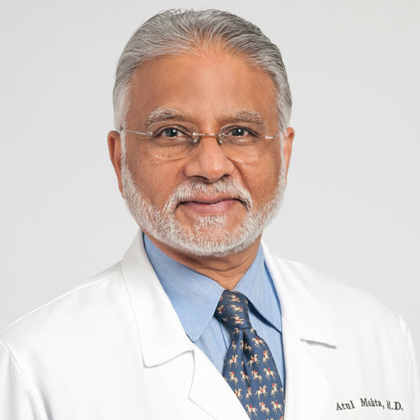

**Naples, November 15th, 2024**

**AORN “A. Cardarelli”**

**Aula Mediterraneo**

**14.00 Greetings from the Authorities**

**14.30 Introduction**

Fausto De Michele (Naples)

Lina Zuccatosta (Naples)

**Chairs:** Stefano Gasparini (Milan), Lina Zuccatosta (Naples)

**15.00 Keynote Address: Historical Perspective on Bronchoscopy: Connecting the dots…**

(A. Mehta, Cleveland, Ohio, USA)

**15.30 Keynote Address: Mistakes I have made as a bronchoscopist!**

(A. Mehta, Cleveland, Ohio, USA)

**16.00** **Bronchoscopy related infections**

(A. Mehta, Cleveland, Ohio, USA)

**16.30 Mediastinal Cryobiopsy**

(L. Zuccatosta, Naples)

**17.00 EBUS-TBNA: not only mediastinum**

(S. Gasparini, Milan)

**17.30**  **Molecular Diagnosis of Lung Cancer via EBUS-TBNA**

(A. Mehta, Cleveland, Ohio, USA)

**18.00**  **Pleural Effusion: Interactive Session**

(A. Mehta, Cleveland, Ohio, USA)